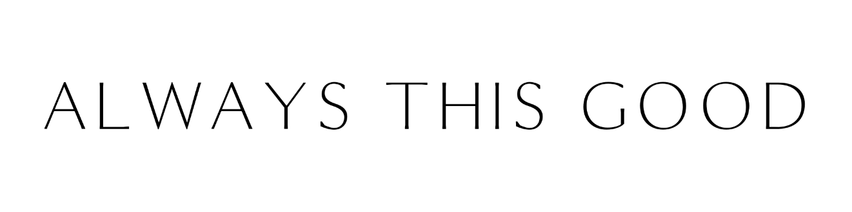
FOR IMMEDIATE RELEASE

JENNIFER MAGGIORE WINNER
IN THE 21st ANNUAL STEVIE® AWARDS
FOR WOMEN IN BUSINESS

Stevie Award Winners Announced in New York on November 8

Phoenix – September 30, 2024 – Jennifer Maggiore, CEO of Always This Good (ATG) Business Consulting, was named a winner in the Achievement in Promoting Life Balance category in the 21st annual Stevie® Awards for Women in Business.

The Stevie Awards for Women in Business honor women executives, entrepreneurs, employees and the companies they run – worldwide. The Stevie Awards have been hailed as the world’s premier business awards.

“It is an incredible honor to be recognized among so many accomplished women from around the world,” said Jennifer Maggiore. “At Always This Good, our mission is to empower women entrepreneurs to achieve remarkable success without sacrificing their health or happiness. Being named a finalist in the Stevie Awards for Promoting Life Balance underscores the importance of this work, and I am grateful for this recognition.”

Maggiore founded ATG to offer “mindful business” consulting after experiencing health issues and burnout firsthand when she was diagnosed with an autoimmune disease during the Great Recession as she and her husband were raising two small children.

“Always This Good is the answer to the growing demand for holistic business strategies that focus not only on success, but on promoting sustainable work-life integration while prioritizing physical, mental and spiritual well-being,” said Maggiore. “We specifically serve women because studies show they’re more likely to start social ventures, create jobs, and give back to their communities.”

Maggiore continued, “Women are often successful at the expense of their health, contend with gender-bias, have less access to capital, and are expected to perform multiple roles in and out of the home, including caregiving. Women are also more likely to experience high achievement as a result of trauma, which is why our team is trained to provide trauma-informed services. We purchased, renovated and opened the Always This Good Retreat Center in Phoenix in 2022, and this year we invested in adopting and training a service animal to work with clients beginning in 2025.”

ATG offers traditional business consulting, a peer advisory membership group and retreats across the U.S., incorporating stress-management techniques including meditation, yoga, chair massage and aromatherapy.

ATG was one of more than 1,500 entries from organizations and individuals in 36 nations and territories that were submitted for consideration this year.

“In its 21st year, the Stevie Awards for Women in Business received an impressive collection of remarkable nominations,” said Maggie Miller, president of the Stevie Awards. “We look forward to recognizing the outstanding achievements of women in the workplace in New York on November 8.”

Gold, Silver and Bronze Stevie Award winners will be announced during a gala event at the Marriott Marquis Hotel in New York City on Friday, November 8. Nominated women executives and entrepreneurs from around the world are expected to attend. The event will be broadcast on Livestream.

Details about the Stevie Awards for Women in Business and the list of Finalists in all categories are available at www.StevieAwards.com/Women.

About Always This Good
Empowered women achieve powerful results.

Always This Good (ATG) exists to create a ripple effect of positive social impact by empowering women business leaders with mindful business consulting services. ATG is unique in that equal emphasis is placed on business acumen and self-care including mental, physical and spiritual well-being.

Services include virtual events and in-person retreats at the ATG Retreat Center in Phoenix, business consulting on retainer, a peer advisory program and unique, sustainable products from women-lead companies that support a healthy lifestyle.

Always This Good Business Consulting, a Phoenix-based, top-ranked firm that integrates business strategy, wellness, mindfulness, and stress management, is led by renowned business consultant, entrepreneur and CEO Jennifer Maggiore. With more than 20 years of experience, Maggiore has been recognized as a leader in supporting women entrepreneurs and executives in achieving professional success while prioritizing wellness.

About The Stevie Awards
Stevie Awards are conferred in nine programs: the Asia-Pacific Stevie Awards, the German Stevie Awards, The American Business Awards®, The International Business Awards®, the Middle East & North Africa Stevie Awards, the Stevie Awards for Women in Business, the Stevie Awards for Great Employers, the Stevie Awards for Sales & Customer Service, and the Stevie Awards for Technology Excellence. Stevie Awards competitions receive more than 12,000 nominations each year from organizations in more than 70 nations and territories. Honoring organizations of all types and sizes and the people behind them, the Stevies recognize outstanding performances in the workplace worldwide. Learn more about the Stevie Awards at www.StevieAwards.com.

###

Always This Good Media Contact:
Michelle Portillo
mvportilloPR@gmail.com
720.323.9751

