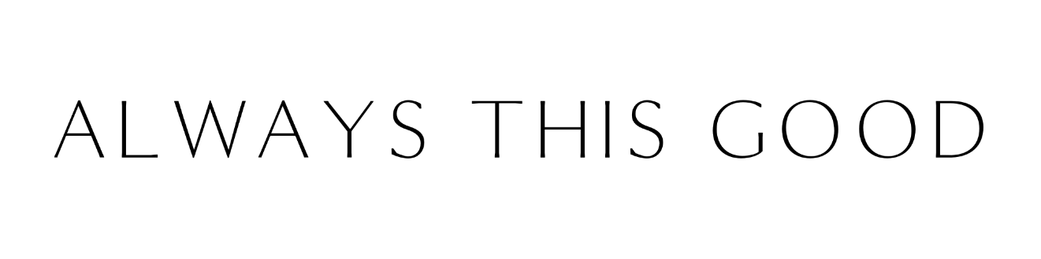
FOR IMMEDIATE RELEASE

ALWAYS THIS GOOD BRINGS COMFORT
AND JOY TO CHILDREN IN CRISIS

ALWAYS THIS GOOD PARTNERS WITH CHILD CRISIS TO CREATE A

WELCOMING HOME FOR FOSTER KIDS THIS HOLIDAY SEASON

Phoenix – NOVEMBER 19, 2024 – Phoenix-based Always This Good (ATG) Business Consulting has teamed up with Child Crisis Arizona to decorate their new residential facility in Mesa to create a brighter future for young people ages 18-21, giving them the chance to thrive in a loving, welcoming environment. Donations can be made through an Amazon wish list, where specific items can be purchased and shipped directly to ATG.

Child Crisis Arizona Chief Executive Officer Torrie Taj and her leadership team recently visited ATG’s newly purchased and renovated retreat center and were so impressed with the interior design that they asked ATG CEO Jennifer Maggiore to take the lead in decorating the residential facility. Although Maggiore is not a designer, she gladly took on the opportunity to help create a warm and welcoming space for these amazing young adults.

"We chose to partner with Always This Good because of their unique approach to design—blending creativity, warmth, and a sense of belonging—which perfectly aligns with our vision for the residential space,” said Torrie Taj, Child Crisis Arizona CEO. “The thoughtful, welcoming space they’re creating will not only provide these young adults with a safe environment but also give them a sense of pride and confidence as they embark on their journey toward independence. This is more than just decorating a house; it's about helping them feel valued, supported, and ready to thrive."

The wish list includes an eclectic blend of bohemian and biophilic elements, with a focus on natural textures and greenery to evoke a sense of tranquility. To add depth and character, the overall aesthetic embraces surprising elements including mixed prints, colorful textiles, and glam lighting fixtures set against bold, dramatic wallpaper, and rich, dark paint. Items start at just $9.99, and donations may be tax-deductible*.

“These young people deserve to live in a space that is not only safe and secure but also a place where they can thrive, feel supported and begin their journey toward independence,” Maggiore said. “Together, we can help create an environment that will nurture their growth, inspire confidence and remind them they are seen and valued.

“Our goal is to have the home ready in a short time ahead of the holidays and we’re asking for support in the form of donations from an Amazon wish list to furnish and decorate the home,” she said. “This holiday season, your donation can make a lasting difference. Whether it's a cozy blanket, a piece of furniture, or any of the other essentials on our Amazon wish list, every gift is a step toward turning this house into a home.”

Child Crisis Arizona provides emergency shelter, foster care, adoption, counseling, early education, and parenting support services to Arizona’s most vulnerable children, youth and families. Their mission is to provide children and youth in Arizona a safe environment, free from abuse and neglect, by creating strong and successful families. For questions about their programing or to learn more, please contact Amy.Vericker@childcrisisaz.org

ATG empowers women business leaders with mindful consulting services that balance business acumen and self-care, including mental, physical, and spiritual well-being. Offerings include virtual events, in-person retreats at the ATG Retreat Center in Phoenix, business consulting, a peer advisory program, and sustainable products from women-led companies. ATG has partnered with Child Crisis Arizona for nearly a decade, providing rebranding and social media consulting, and most recently offering pro bono expertise to support the organization’s growth.

* Amazon will not share who made a donation - please reach out directly to Always This Good for a copy of the tax-deductible donation letter from Child Crisis Arizona.

###

Always This Good Media Contact:
Admin@alwaysthisgood.com
480-270-5395

