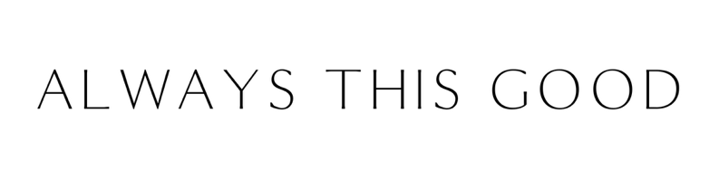
PRESS RELEASE

FOR IMMEDIATE RELEASE
June 30, 2025

Always This Good CEO Jennifer Maggiore
Named One of Phoenix’s Titan 100 Business Leaders

Always This Good is pleased to announce that Jennifer Maggiore, CEO, has been named a 2025 Phoenix Titan 100. The Titan 100 program recognizes Phoenix’s Top 100 CEOs & C-level executives. They are the area’s most accomplished business leaders in their industry using criteria that include demonstrating exceptional leadership, vision, and passion. Collectively, the 2025 Phoenix Titan 100 and their companies employ over 349,000 individuals and generate over $43 billion in annual revenues.
“Being named as one of the top 100 business leaders in the region truly an honor,” Maggiore said. “I’m grateful for the recognition it brings to our hard-working team, our inspiring clients, and the transformative community around Always This Good. They’ve helped champion a new kind of leadership, one that values spirituality, connectedness, and emotional intelligence just as much as business acumen. Together, we’re building mindful, sustainable organizations that create meaningful impact.”
Since founding Always This Good in 2005, Maggiore has become a sought-after advisor, retreat facilitator, and speaker known for her bold vision, authentic leadership, and ability to create transformative growth for her clients. At Always This Good, traditional business strategy is seamlessly blended with wellness practices, including meditation, yoga, aromatherapy, and chair massage, within consulting services, retreats, and peer advisory programs. In 2022, Maggiore purchased, renovated, and opened the Always This Good Retreat Center in Phoenix. In 2024, the team welcomed the addition of a therapy dog-in-training, who now visits select retreats and events.
Maggiore will be honored at the Titan 100 awards event on September 25, 2025, at Chateau Luxe.
# # #

